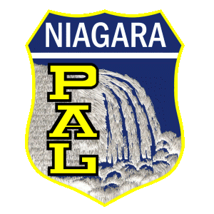

Niagara PAL Instructional Golf

2014 Information Form

Name of Child ___________________________________________

Parent/Guardian Name _____________________________________

Address ___________________City ___________ State __________Zip _________

Telephone _________________Age ____________Grade __________

Name of School ___________________________

Emergency Contact Information

Name ____________________________

Relation __________________________

Phone ____________________________

I give permission for my son/daughter ____________________ to participate in the

Niagara PAL Instructional Golf Program.

Parent/Guardian Signature _____________________________ Date ____________

